Installation of the Matlab Interface for Breiman's randomForest

The Matlab functions (RFClass.m, RFReg.m and RFPrint.m) and compiled Fortran code (RFClassification.dll and RFRegression.dll) must be stored in a directory in the Matlab search path, for example, C:\Matlab6p5\work.

Examples

Two examples are used to demonstrate the function usage; one for classification and the other for regression. The following lists part of the code and results from the example for classification (Example_Classification.m).

% Run RF on Training set
traindata = textread('satimage_tra.txt');
x = traindata(:,1:(end-1));
y = traindata(:,end);
y(y==7) = 6;
cat = ones(1,size(x,2));
classwt = ones(1,length(unique(y)));
param = [50 2 6 0 1 ...
1 0 0 0 0 ...
0 1 0 0 123];
out = RFClass(param, x, y, cat, classwt)
printRF(out);

% Plot Variable Importance
figure;
bar(out.errimp, 0.1);
title('Variable Importance');
xlabel('');
ylabel('');

The results are a confusion table shown on the Matlab command window and a plot for variable importance.

Number of Trees: 50
No. of Variables tried at each split: 2
OOB estimate error rate for training data: 9.8083%

Confusion Matrix For Training Set
| 1 2 3 4 5 6 | err %
-----|-------------------------------------|---------
1 | 1050 2 15 0 5 0 | 2.0522
2 | 1 468 1 2 3 4 | 2.2965
3 | 6 1 921 22 0 11 | 4.1623
4 | 7 4 84 237 3 80 | 42.8916
5 | 32 4 1 4 393 36 | 16.3830
6 | 1 0 29 60 17 931 | 10.3083

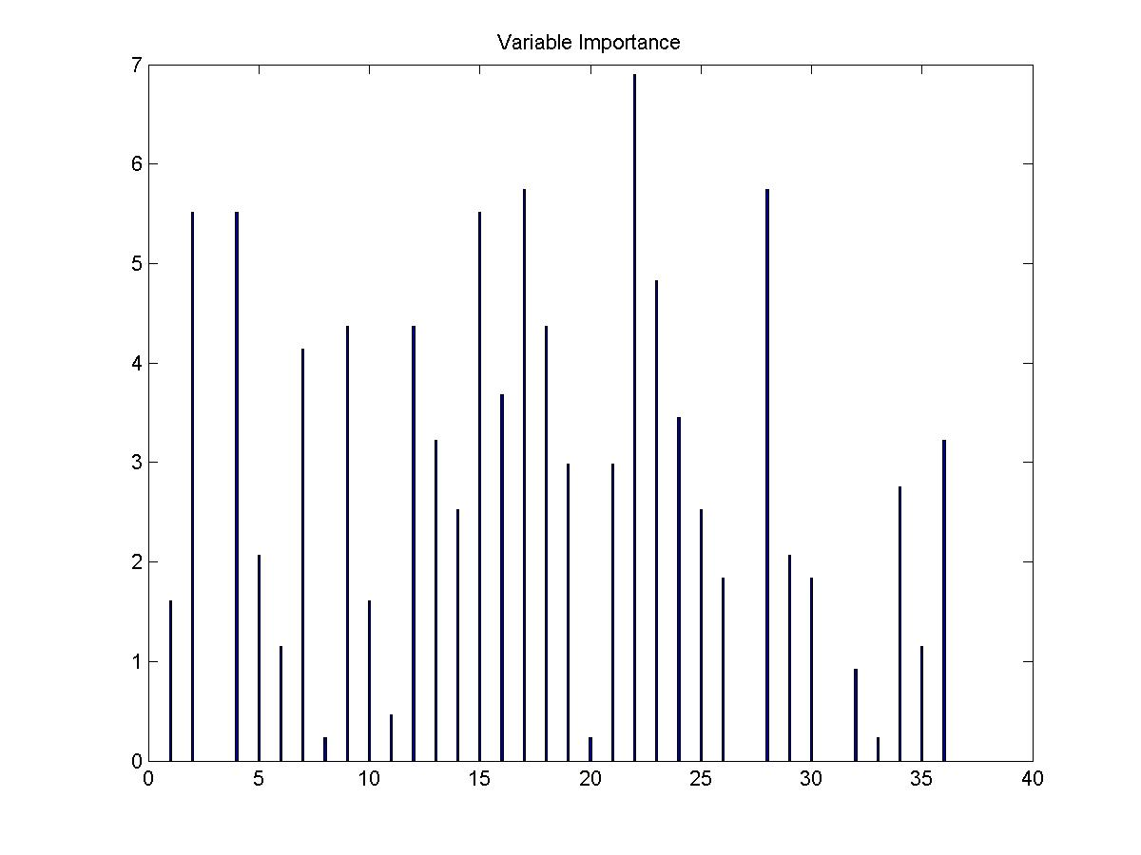
You can also view the function usage in details using the "help" command.

>> help RFClass

!
! Description:
!
! RFClass implements Breiman's random forest algorithm for classification.
! It can also be used in unsupervised mode for locating outliers or
! assessing proximities among data points.
! (based on Breiman and Cutler's original Fortran code version 3.3)
!
! Usage:
!
! param = [ntree, mtry, nclass, iaddcl, ndsize, ...
! imp, iprox, ioutlr, iscale, ipc, ...
! inorm, isavef, mdimsc, mdimpc, seed ];
! out = RFClass(param, x, y, cat, classwt);
! out = RFClass(param, x, y, cat, classwt, xts, yts);
! out = RFClass(param, xts, yts, forest);
! PrintRF(out);
!
! Arguments:
!
! param A row-vector for the 15 parameters described below.
! ntree Number of trees to grow. This should not be set to too small a number,
! to ensure that every input row gets predicted at least a few times.
! mtry Number of variables randomly sampled as candidates at each split.
! nclass Number of class in training set.
! iaddcl Should add a synthetic class to the data?
! =0 do not add;
! =1 label the input data as class 1 and add a synthetic class by randomly
! sampling from the product of empirical marginal distributions of the input;
! =2 is similar to =1, but the synthetic data are sampled from the uniform
! hyperrectangle that contain the input.
! ndsize Minimum size of terminal nodes. Setting this number larger causes smaller
! trees to be grown (and thus take less time).
! imp Should importance of predictors be assessed? (>0 for Yes)
! iprox Should proximity measure among the rows be calculated? (>0 for Yes)
! ioutlr Should outlyingness of rows be assessed?
! iscale Should compute scaling coordinates based on the proximity matrix.
! ipc Should compute principal coordinates from the covariance matrix of the x's.
! inorm Should normalize all variables before computing the principal components.
! isavef If set to 0, the forest will not be retained in the output object;
! set to 1 to retain forest in the output object;
! set to 2 to save forest to the file 'rforest.txt' (old file will be overwritten).
! mdimsc Number of scaling coordinates to be extracted. Usually 4-5 is sufficient.
! mdimpc Number of principal components to extract. Must < m-dim.
! seed Seed for random number generation.
!
! x A m by n data matrix of m samples and n variables containing predictors
! for the training set.
! y A response column-vector for the training set.
! cat The vector for variable type. (=1 for continuious; =0 for categorical)
! classwt Priors of the classes. Need not add up to one.
! xts A p by n data matrix (like x) containing predictors for the test set.
! yts A response column-vector for the test set.
! forest A returned object for the Forest.
!
! Output Values:
!
! type Object tag.
! cat Used categorical vector.
! param Used parameter vector.
! mtab The confusion matrix for training set.
! mtabts The confusion matrix for test set.
! errtr Error rate for training set.
! errts Error rate for test set.
! ypredtr The predicted values of the input training set based on out-of-bag samples.
! ypredts The predicted values of the input test set based on out-of-bag samples.
! imp Vector of variable importance.
! predimp The matrix of predict importance.
! classwt The priors of the classes.
! ndbtrees The vector stored the length of each tree.
! trees The forest in matrix containing
!

Comments and bugs report

Please contact me. Thanks.

Ting Wang
Biometrics, Merck & CO.
(732) 594-1216
tingchuan_wang@merck.com

